Credit Card Fraud detection implementation in R

creditdata <- read.csv(file.choose(), header = TRUE). // Import the data into R studio
str(creditdata). // It gives the structure of the data

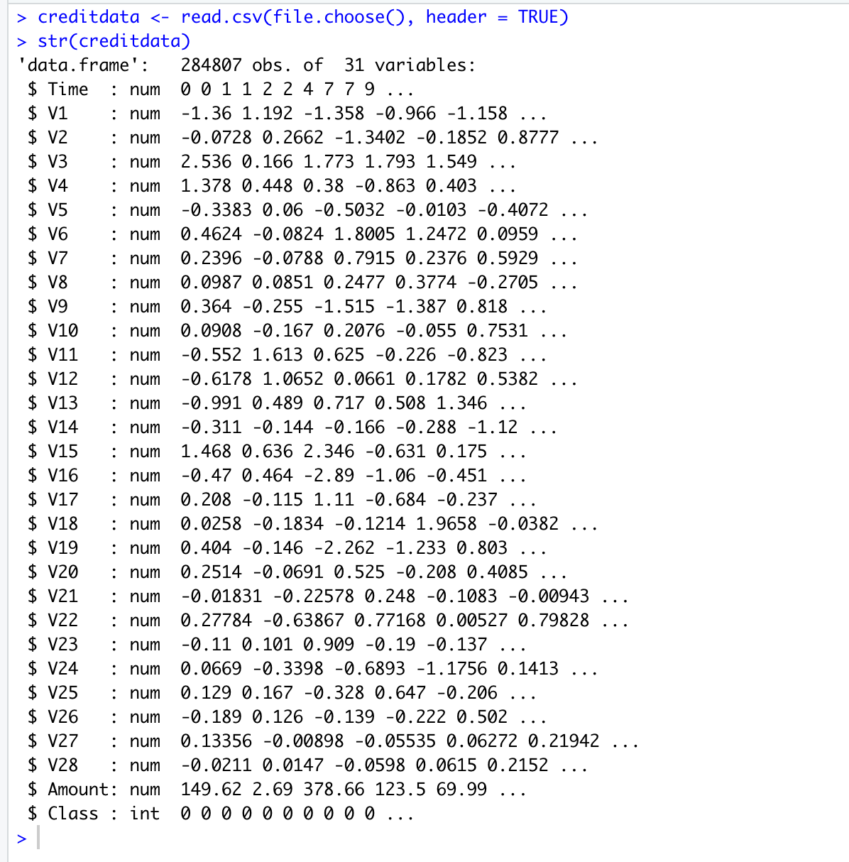

summary(creditdata) // It gives summary of the data

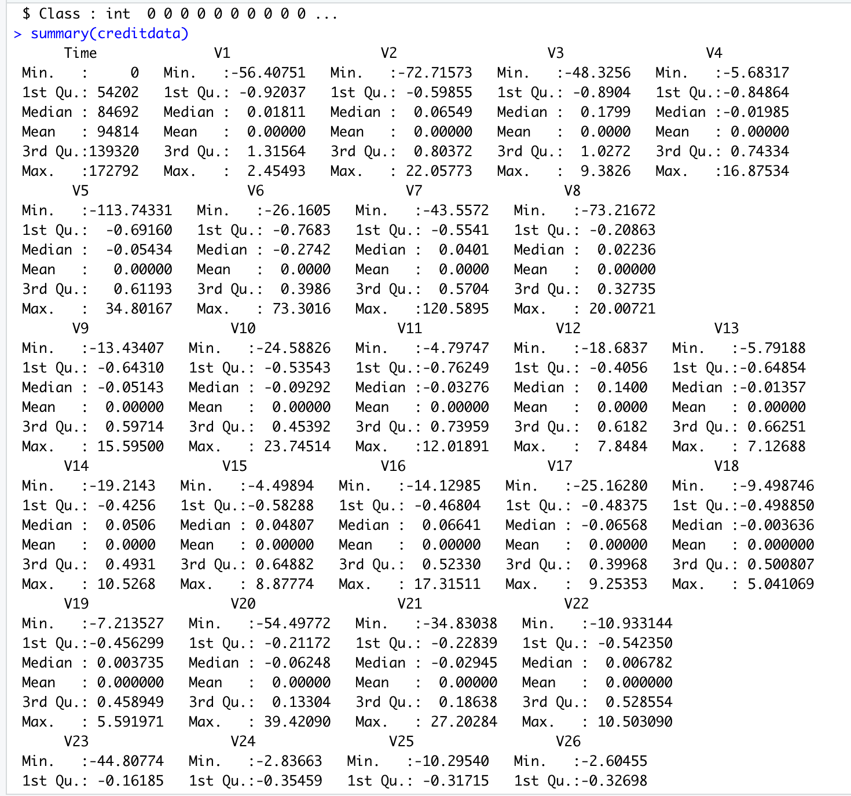

table(creditdata$Class) // This gives how many 0’s and 1’s in the data under class variable

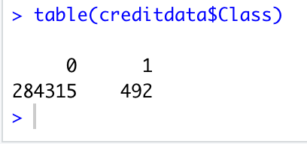

// Split the data set into training and testing
set.seed(3456)
dt = sort(sample(nrow(creditdata), nrow(creditdata)*.7))
train<-creditdata[dt,]
test<-creditdata[-dt,]

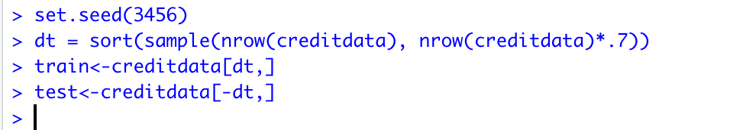

LogisticModel=glm(train$Class~.,family=binomial(),data=train) // Create logistic model

summary(LogisticModel). // It gives summary of the model that we created

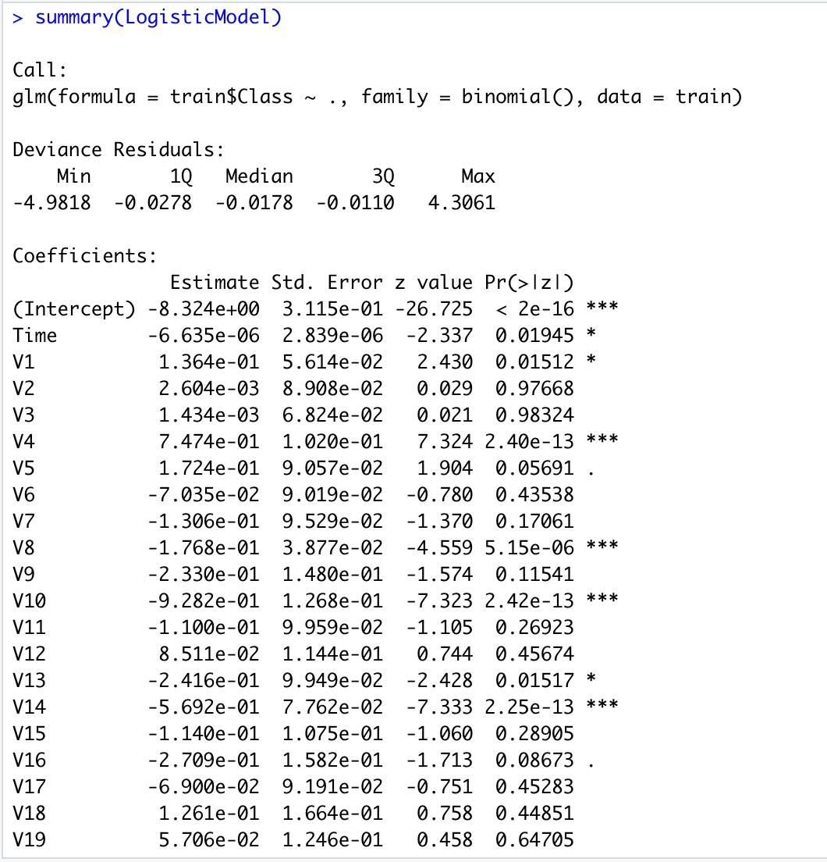

// Predicts the class values for test data using the logistic model that we created earlier
predicteddata <- predict(LogisticModel,test, type = "response")

// Create a table for class variable of predicted values vs actual values
table(actualvalue=test$Class,predictedvalue = predicteddata >0.5)
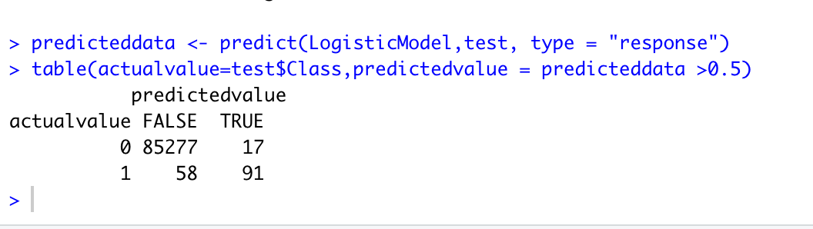

# calculate accuracy of the predicted values

= (85277+91)/( 85277+91+58+17) = 99.12%

# plot the accuracy that we predicted

acuracyPD = prediction(predicteddata,test$Class)
acuracyPF <- performance(acuracyPD,"tpr","fpr")
plot(acuracyPF, colorize = TRUE,print.cutoffs.at = seq(0.1,by=0.1))
